**HOME Page**

**Logo is incorrect and there’s a lot of extra space. Top bar should squeeze a little after scrolling below but it should not vanish.**

**Sliders text**

1.

Top notch Medical Billing Services

We take care of your RCM services as if they are our own.

2.

Worry about patients, not about money

You take care of patients and let us do all the leg work to bring maximum reimbursements.

3.

Build it your way

We adapt to your workflow and routine.

**Three blocks under main slider should also contain the same text as above**

Remove the current topics after slider and blocks and add WHY CHOOSE US section below

WHY CHOOSE US?

01.

Billing accuracy

99% billing accuracy – we make sure each claim we submit goes through validations to make it clean.

02.

Daily Work

Daily work on pre-bill, clearing housing, and insurance rejections.

03.

Our billing system

You’ll always have access to your billing system and records. We work through your servers.

04.

Timeliness

We make sure to submit claims within 24 hours of receiving

05.

Aggressive follow-up

Aggressive follow-up on all submitted claims not paid within 60 days.

06.

Happy Client

We are very strict when it comes to HIPPA compliance. Your trust is our religion.

**Remove specialized services and replace it with below section.**

SPECIALTIES WE HANDLE

* Acupuncture
* Allergy & Immunology
* Anesthesia
* Behavioral Health
* Cardiovascular Surgery
* Cardiology
* Chiropractic
* Colon & Rectal Surgery
* Critical Care
* Dermatology
* Diagnostic Services
* Durable Medical Equipment
* Evaluation and Management -Family Practice
* Endocrinology
* Ear, Nose, and Throat
* Gastroenterology
* Gastro-Intestinal Surgery
* General Surgery
* GI Clinic/Gastro-Enterology
* Hematology
* Hematology and Oncology
* Infectious Diseases
* Inpatient Medicine
* Internal Medicine
* Interventional Radiology
* Naturopathy
* Nephrology
* Neurology
* OB-GYN
* Observation Care
* Occupational Therapy
* Oncology
* Ophthalmology
* Orthopedics
* Pain Management
* Pathology
* Pediatrics
* Physical Therapy
* Plastic Surgery
* Podiatry
* Preventive Care
* Pulmonary & Sleep Medicine
* Radiology
* Rheumatology
* Urgent Care
* Urology

**About Us**

Slider doesn’t work. Please fix it.

Please change the text under Out Motto to following.

Our motto is to provide accurate medical billing services to our valued clients and increase their reimbursements. It is our belief that it is a failure of a medical billing company if its clients have to worry about monthly payment cycles.

Please remove the HIPAA compliant logo and also the big bold text alongside it.

**Revenue Cycle Management**

Again, slider doesn’t work. Please fix it.

Chang the text of Our Motto from above.

Remove everything from We specialize as these are mixed items from specialties and services. Here we should provide graphical flow of revenue cycle management and then write the steps in text.

Put below text and then graphical flow.

What is RCM?

Revenue cycle management (RCM) is the financial process, utilizing medical billing software that healthcare facilities use to track patient care episodes from registration and appointment scheduling to the final payment of a balance.

**Note: Please put HTRCM logo in second first circle below.**

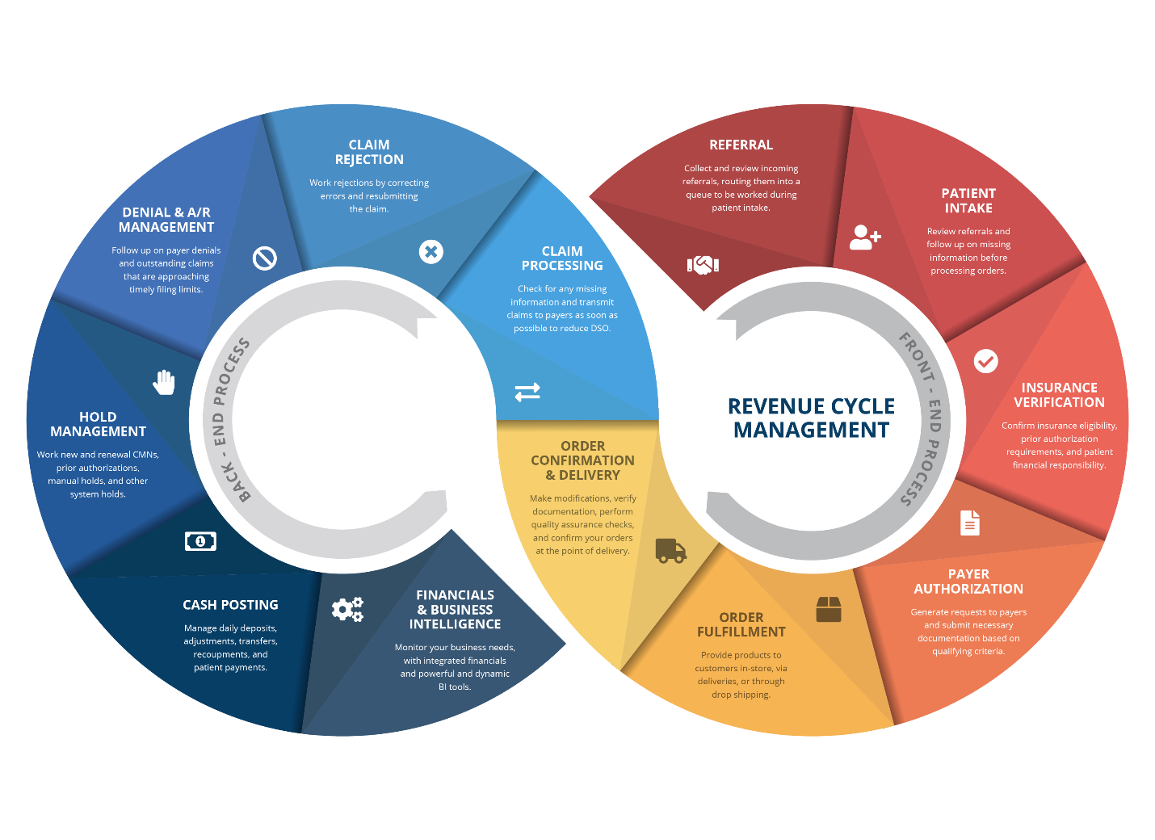

**Services**

Again, the slider doesn’t work. Please fix it.

Remove We from Provide and everything else after and replace it with below.

1. Medical Billing and Coding

The single most important element to guaranteeing reimbursements is proper medical billing and coding. Even the smallest mistake can result in a delay of payment.

2. Comprehensive Chart Auditing

Auditing ensures that your charts are accurate and in compliance with the complex updates and often fluctuating rules and regulations of the billing and coding world.

3. Managing Work Flow / Training

Our professionals are available to manage and educate your staff on compliance and streamlining workflow, to maximize productivity. Think of us as an extension of your staff.

4. Credentialing

Credentialing is a basis of starting a clinic or healthcare facility. They also lay the root for your relationships with insurance companies as well as patients.

5. Contracting

HTRCM will obtain and negotiate contracts with insurance payers. We ensure your contracts with insurance carriers are up-to-date and attain the highest reimbursement rates.

6. Complete Patient Billing

HTRCM professionally takes very good care of complete patient billing services for your practice, so you can focus on what is the most important: quality patient care.

**Contact Us**

Please overhaul this page. It contains huge blank space and template information. Please update correct HTRCM contact info. Make the contact us form simple. Remove DOB and SSN boxes. Remove select department as well. It’s not Online Appointment Form. It’s a Contact Us form.